Alnwick Area Forum
Proposal for Discussion

Aim of the Forum

The broad aim of the Alnwick Area Forum is to provide an opportunity to bring together issues affecting the whole of Alnwick locality and consider appropriate solutions.

Background

Under the new arrangements for the local authority and partnership structures resulting from local government reorganisation, the county is divided into three service areas (North, West and South East) and 27 localities (see appendix 1). The three area committees and three area partnerships are now established and work is well underway to set up 27 community forums (over 20 are now established and addressing local issues).

Community forums are seen as fundamental to Northumberland County Council’s approach to encouraging citizens to shape the places in which they live and work. The County Council wants to make sure it has strong links with its communities and its success will, in part, be measured by this. The protocol for community forums (available from www.nsp.org.uk) sets out some key principles for community forums. They are seen as being open and inclusive with no fixed membership. Appendix 3 sets out the structure for engagement and shows how community forums feed into the Northumberland Strategic Partnership (NSP).

Parish and town councils have a key role to play in community forums, but are also able to feed into the County Council and its area committees. Some areas have set up clusters of parish councils which bring together parish and town councils with similar characteristics to discuss issues and concerns and look at the potential for joint solutions. Glendale has a strong cluster of parish councils (Glendale Group of Parish Councils), which is separate to the Glendale Community Forum – although the group (as well as individual parish councils) plays an active part in the community forum.

Structure of the Alnwick Area Forum

The main issue to consider is whether the Alnwick Area Forum is a parish council cluster or a community forum with other groups and interests represented. Each has a separate role to play and some localities (such as Glendale) have both a cluster of parish councils and a community forum. Key differences between the two include the following:
- A cluster of parish councils will feed into the democratic process (ie Northumberland County Council) whereas a community forum will feed into the participatory process (ie NSP) – see appendix 3.
- A cluster of parish councils is made up purely of parish council representatives while a community forum has representatives from a range of voluntary and community sector organisations, public sector agencies, businesses and individuals as they are about understanding their views first hand and using that to influence services of the council and other partners.
- A cluster of parish councils is expected to generate its own administrative costs though precepts, if necessary, whereas funding is available through the County Council to support hosting arrangements for a community forum reflecting the costs associated with engaging with the wider community.
- Community forums are not necessarily about formal meetings and formal minutes, but may take another form to suit local need or topic.
- Community forums are open to all and everyone who attends is entitled to express opinions on the topics under discussion and these opinions will be taken into consideration when developing new service delivery policy.

The Alnwick Area

There are a number of sub forums or groups in the Alnwick locality which could feed into the Alnwick Area Forum through nominated representatives. These include (see appendix 2 for geographical coverage):

- Alnwick Community Partnership – Alnwick Community Development Trust and Alnwick Town Council have led on developing a community partnership for Alnwick town incorporating the unelected interests of the town (community and voluntary sector organisations and other special interest groups). The initial meeting of the Community Partnership was held on 17th March. The group elected a chair, vice chair and committee (steering group) members and agreed that Alnwick Community Development Trust would act as host. The group also discussed priorities for the town plan and ways to widen engagement to other members of the community. In addition, a community week of action is currently being organised by Homes for Northumberland, the Development Trust and Alnwick Extended Services Partnership for 1st to 6th June which should have strong links to the work of the community partnership.

- Mid Coquet – Early discussions centred around a wish to set up a cluster of parish councils in the south Alnwick area. Subsequent discussions suggested this could be widened to include representatives from other organisations in the area to form a South Alnwick community forum, since renamed ‘Mid Coquet’ Community Forum. Parish councillors David Rixon and Len Welch were elected as chair and vice chair. A wider meeting will be held on 26th April and advertised widely within the local area. The event will focus on issues related to broadband and highways.

- County Councillor John Taylor’s Parish Council Cluster – Cllr John Taylor meets with representatives of the parish councils in his ward to discuss issues of relevance to the wider area.

As can be seen from the map at appendix 2, a number of communities are not included within these, namely those in the parishes of Alnham, Callaly, Glanton and Whittingham in the west and Lesbury, Alnmouth, Warkworth and Shilbottle on or near the coast.

These sub groups vary in their membership from exclusively parish councils to any organisation wishing to be involved. Depending on whether the Alnwick Area Forum develops into a cluster of parish councils or a community forum, membership of the sub groups may require further thought, as will the route to engage with other communities not covered by the sub groups.

Issues

The Area Forum will provide the opportunity to consider issues and priorities common to all areas. Examples may include car parking in Alnwick town and other issues resulting from the fact that Alnwick acts as a service centre for the whole locality (eg shopping, transport, health services, library service, advice services etc). Other issues such as employment and those relating to the environment may also be appropriate to consider.

Northumberland County Council’s InfoNet team is undertaking two activities which may help the Area Forum determine its priorities:

- Area Profiles – Area profiles contain statistical information from a range of sources (including the Census and recent Place Survey) which can be viewed at locality level to identify issues relevant to the area. The profiles can be accessed online via www.northumberlandinfonet.org.uk/area_profiles/infonorthumberland/default.htm

- Parish Plans – The InfoNet team has collated a variety of existing local plans (including parish plans) and analysed them for each locality, pulling out common threads that affect the wider locality. There are a number of plans for the Alnwick area and it is anticipated that the analysis of the Alnwick locality will be completed shortly.

These two activities, along with a range of other local information for the locality will be summarised into a further document by the middle of April.

Views are requested from potential participants in the Area Forum – especially around whether it should operate as a cluster of parish councils or a community forum. The County Council currently has a commitment to ensure all localities have a community forum, and if the Alnwick Area Forum develops into a cluster of parish councils, the County Council will need to consider how to develop a community forum for the Alnwick locality.

Comments can be submitted to Alan Lawson, Clerk to Alnwick Town Council, via letter to;

The Clerk
Alnwick Town Council
Cemetery Lodge Office
South Road
Alnwick
NE66 2PH

Or by email to;

susanpatience954@btinternet.com

Appendix 1 – Localities

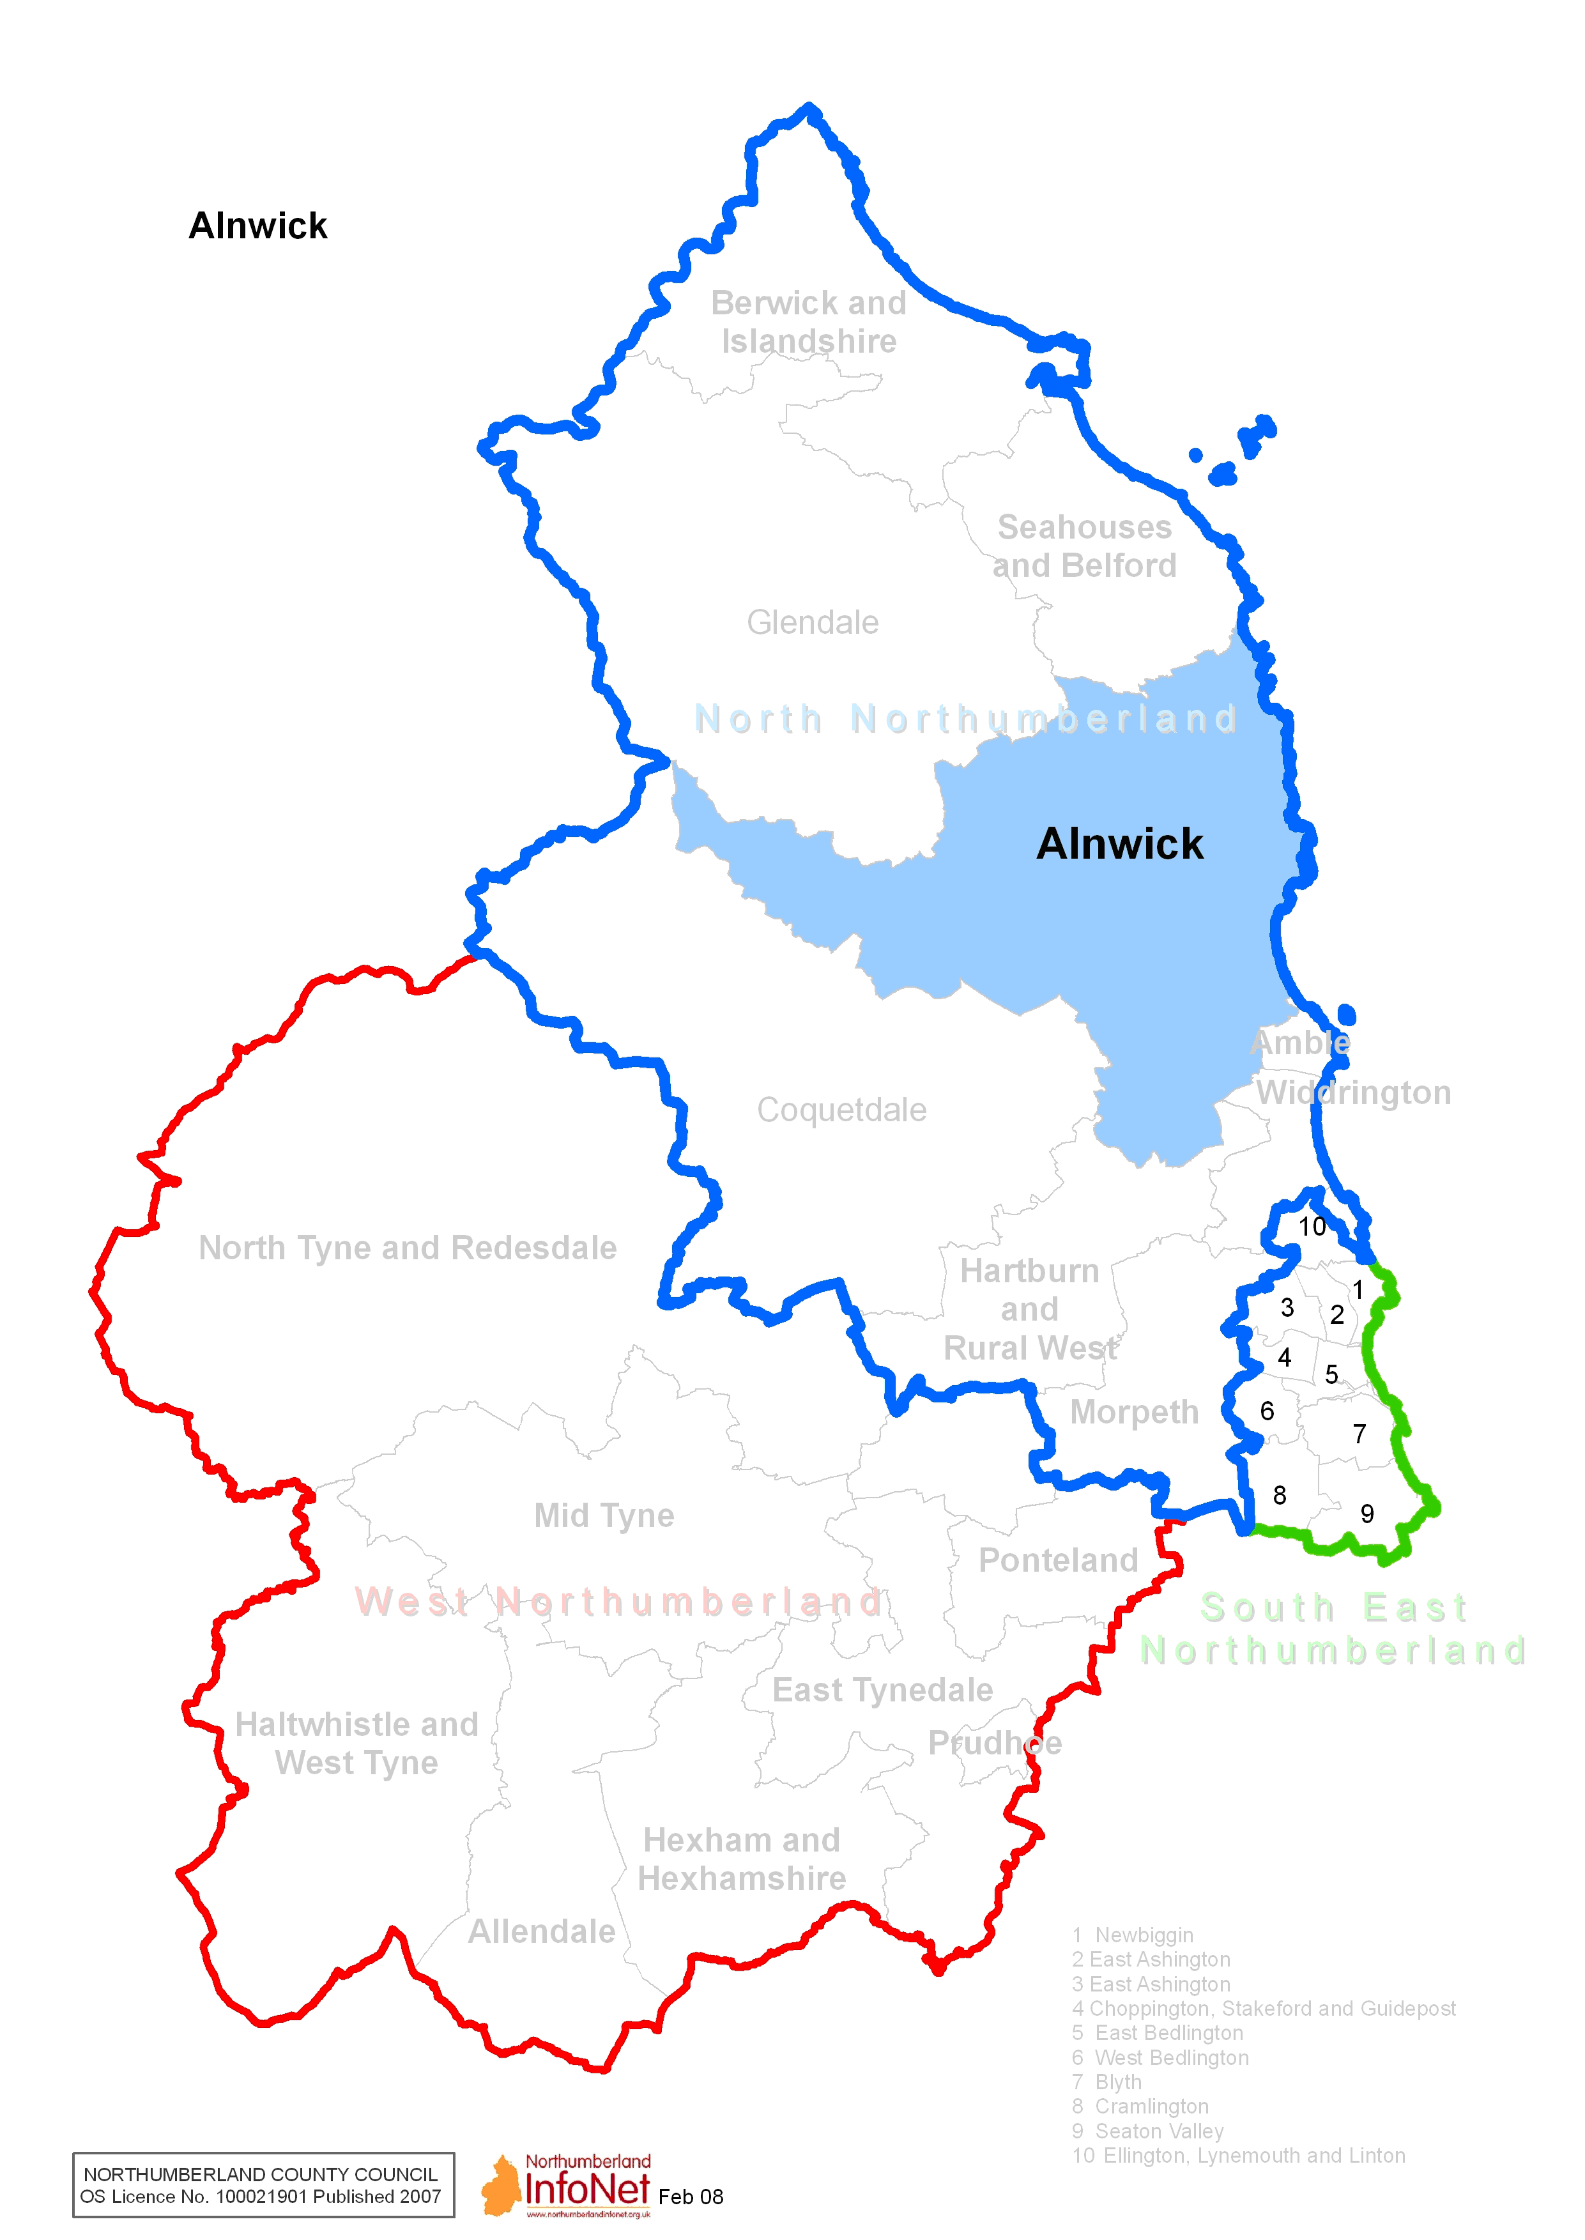
Appendix 2 – Sub Areas

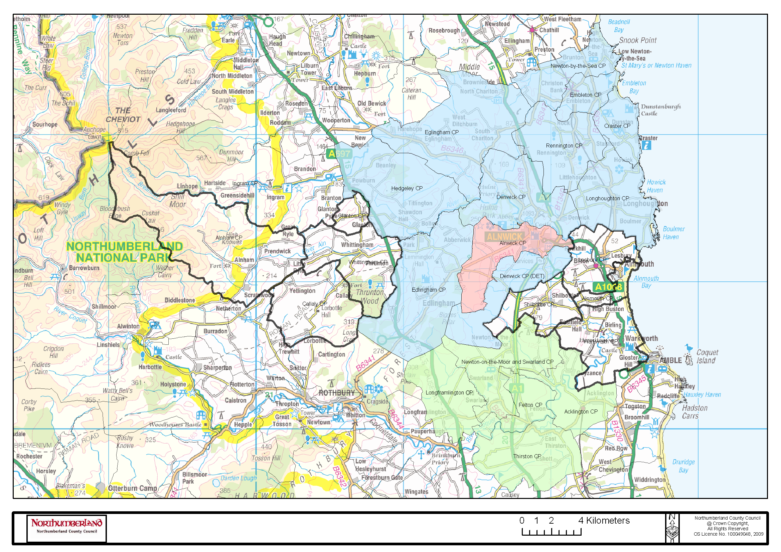
Appendix 3 – Engagement in Northumberland

County Council
NSP

Area Partnerships
Parish and
Town
Councils
Community
Forums

Area Committees

Strategic Leadership
Place Shaping
Localism
Democracy
Participation
Parish
Council
Cluster

Appendix 4 – Approach in Alnwick

NCC North Area Committee
Alnwick Area Forum
(covering whole Alnwick locality and looking at issues common to all areas)
Sub Areas
(with local plans and priorities)
NSP North Area Partnership
Depending on structure of Area Forum

